Introduction to Computer Vision – HW2

Moshe Amini – 204000103

Roie Danino – 316440296

31 December 2017

Hybrid Images

(You might want to play with the zoom track bar of this word document)

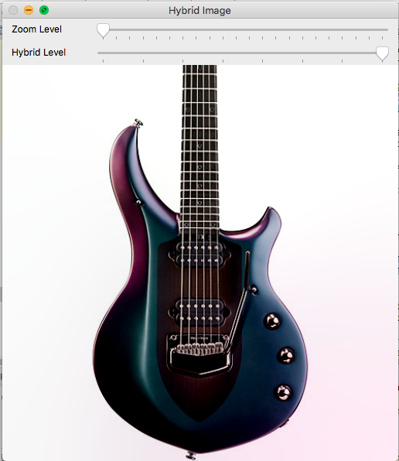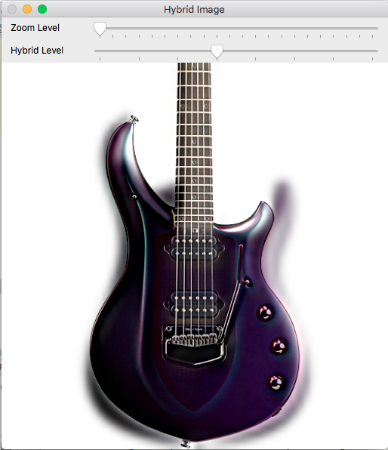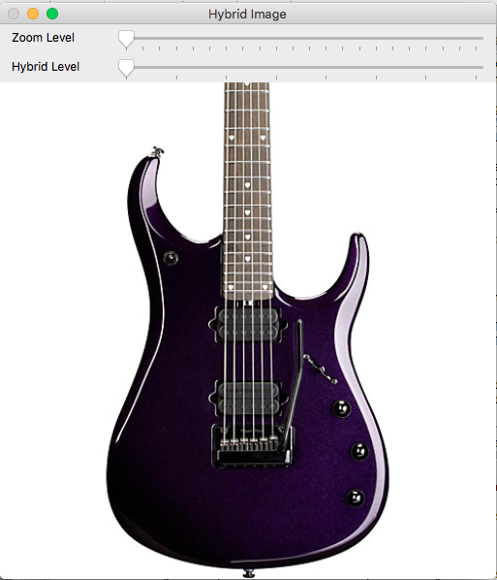

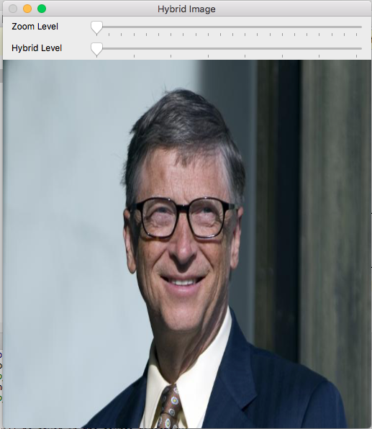

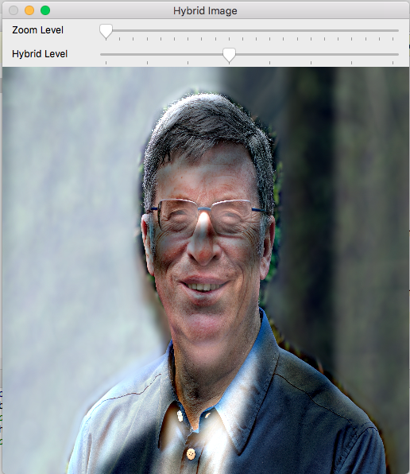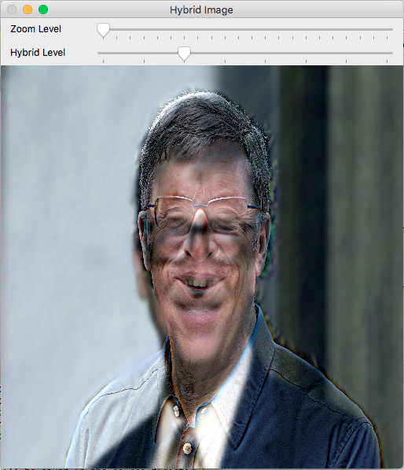

**Abstract**

A hybrid image is an image that shows you different images when looking from different distances and perspectives, so when you look closely you’ll see one picture and another picture from a more distance perspective, the required functionality in this project is to make a simple program that gives the user the ability to choose any 2 images from his computer and to “hybrid” them, with a full control of the zoom and the distance that he will start to see the other image from, using track-bars on the graphical user interface.

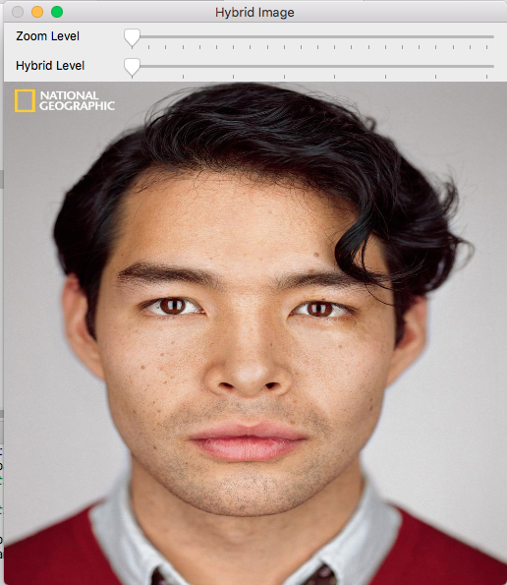

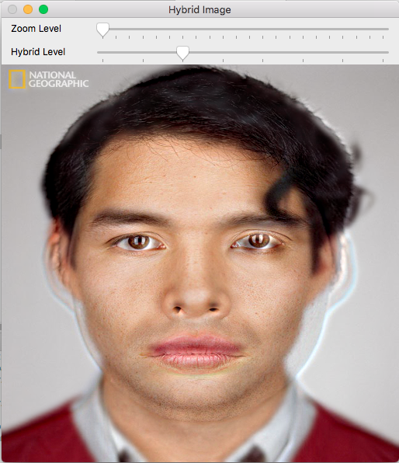

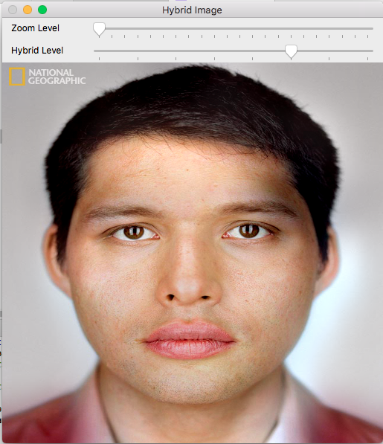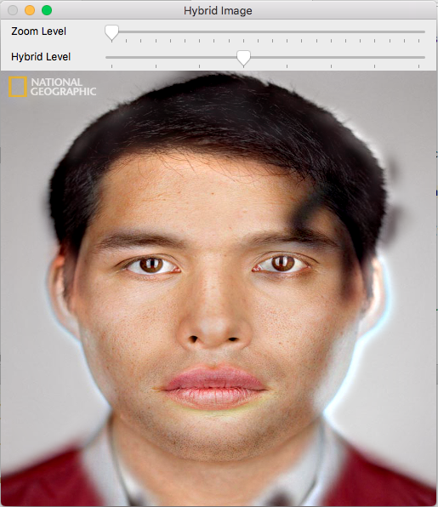

**Introduction and Background**

Designers, artists, and visual scientists have long been looking for ways to make multiples meanings out of a single image. The Mona Lisa’s smile seems both present and absent at the same time, Salvador Dali’s ‘double image’ paintings contain hidden figures and meanings. Many well-known visual illusions cause the viewer to experience different interpretations of the exact same image. This document presents examples of one way to make multiple meanings out of a single hybrid image, which is an image that look different depending on viewing distance or size.

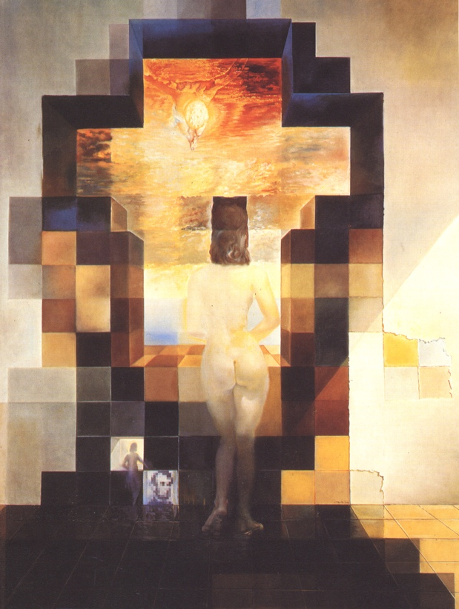

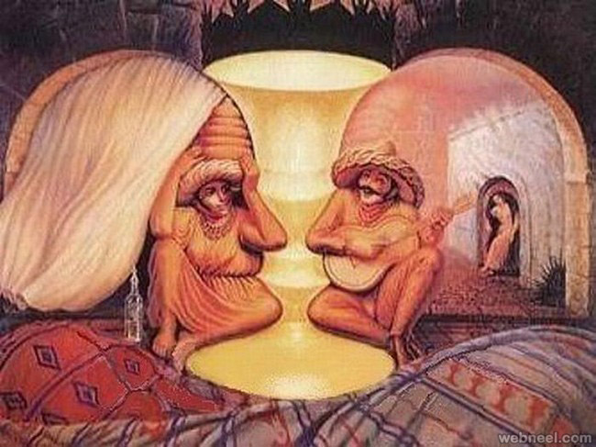

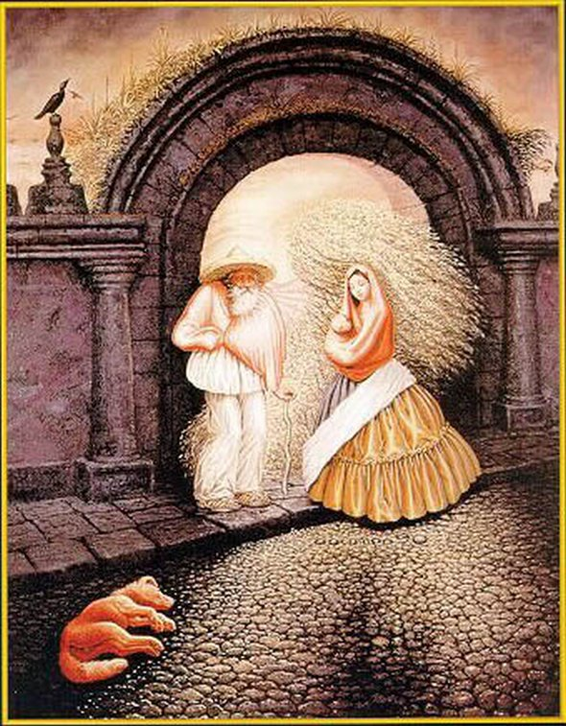

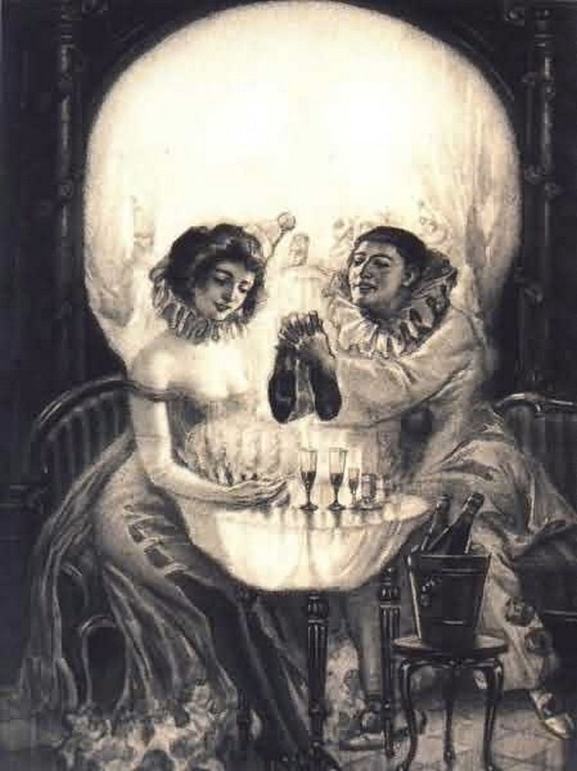

**The Algorithm**

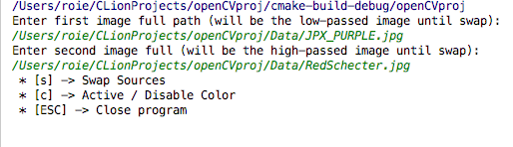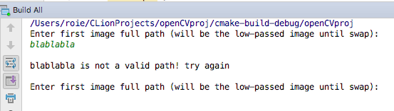**Hybrid Images** are, in fact, some sort of combination between 2 digital images, so the first step will be reading those images, in this project we gave the user the option to choose any 2 photos from his computer, using the console / command line /terminal, before the graphical user interface pops up, it’s also important to check those paths are valid with Mat.empty() function just after reading it so the program won’t crush trying accessing the picture in the algorithm, as you can see, the program will ask you again for the path, so the user wouldn’t need to restart the program just because he did a little mistake with the image path.

After reading those 2 photos successfully, we would like to resize both images to the same size for compatibility reasons, otherwise we wouldn’t be able to continue to the algorithm if the images are not in the same size originally, because eventually we will need to sum those photos or their Gaussians / Laplacians together which are in the same size of the originals.

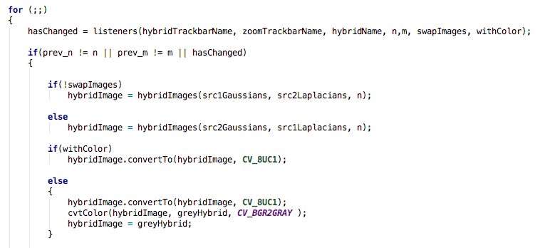Now, when those photos are in the same size, we can start with creating Gaussians pyramids and Laplacians pyramids, creating the Gaussians using pyrDown to half the size in each dimension, then, pushing it into their Gaussians vector which will store all of that photo Gaussian pyramid, for the Laplacians we will resize the pyred-down image to its original size, then subtract the original one from that one, which is the subtraction of the low-pass that will give us the high-pass image, the result of the subtraction will be inserted into the Laplacians vector of that image, doing that iteratively given number of times we thought 7 levels are enough, so the user will have a track-bar with 7 scales and he would be able to choose what level of Gaussian to take from one picture which will be also the amount of Laplacians we will add from the other image.

For nice and comfortable user interface, we will use track-bars to control the “hybridation” level which is the level of the Gaussian of one image and the number of Laplacians from the other picture, we will also want the user to be able to switch between – color and grayscale and between the image in the low pass and the image in the high pass so for purpose we will sample the keyboard and the track-bars in an infinite loop, notice that we only calculating a new hybrid image if a change was required for better performance and efficiency.

The hybrid image calculation in real-time

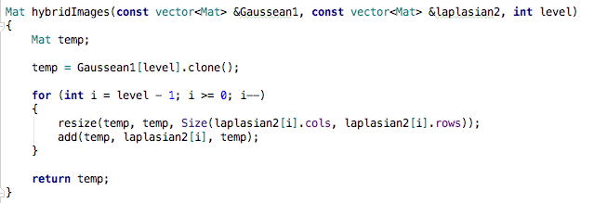

**Results**

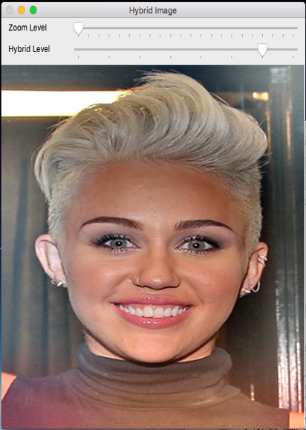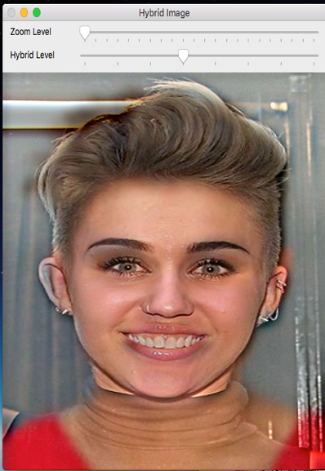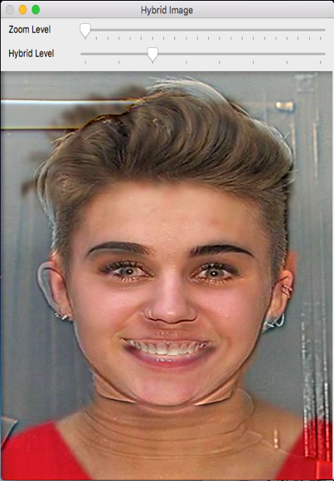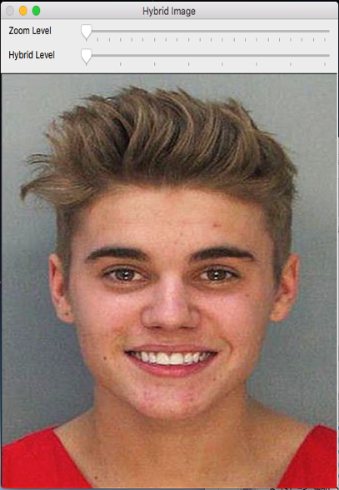

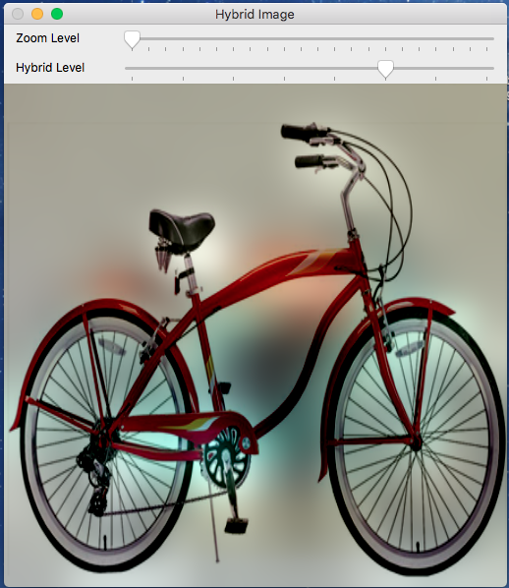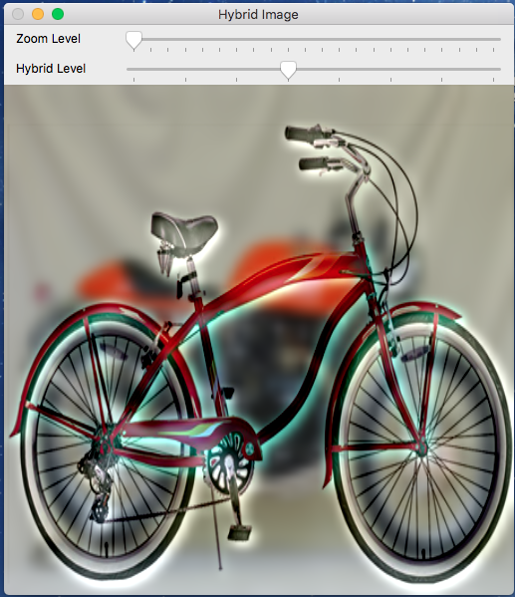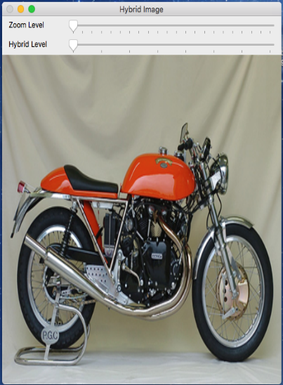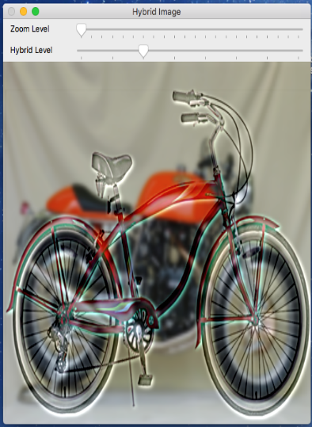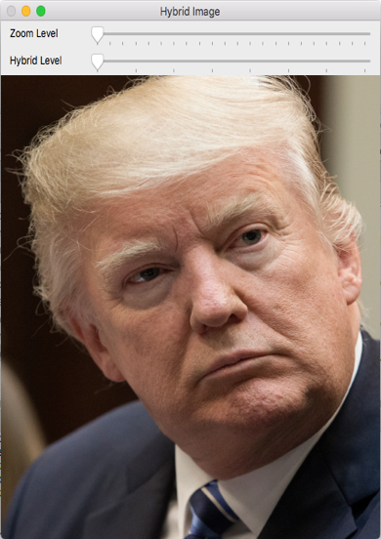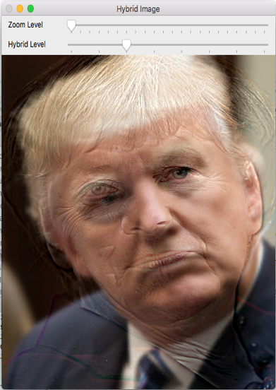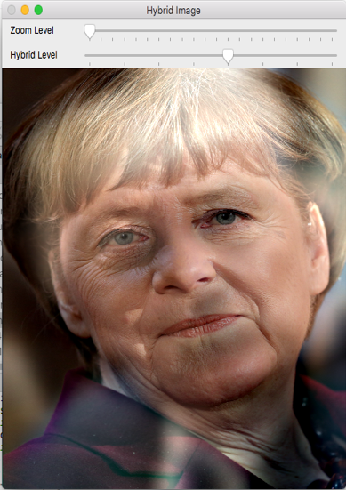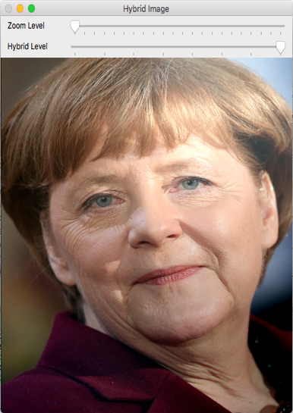

**Summary and Conclusion**

In conclusion, hybrid images and multiple meaning photos are an interesting concept that catch peoples and visual scientists eyes for years, it's nice to look at them but there is not much more than that, we didn't find any real application or use for this functionality, the implementation with open cv is not so hard with the right understanding of concept and how low-pass and high-pass filters work.

**References**

<https://jeremykun.com/2014/09/29/hybrid-images/>

<http://cvcl.mit.edu/papers/Oliva-HybridImages-ArtPerception2013.pdf>

**Appendix**

*//  
// Created by Moshe Amini and Roie Danino on 18/12/2017.  
//*#include **"opencv2/imgproc/imgproc.hpp"**#include **"opencv2/imgcodecs.hpp"**#include **"opencv2/highgui/highgui.hpp"**#include **<opencv2/opencv.hpp>**#include **<iostream>  
  
using namespace** cv;  
**using namespace** std;  
  
**void** createPyramid(**const** Mat &src, vector<Mat> &gaussians, vector<Mat> &laplacians, **int** levels);  
  
Mat hybridImages(**const** vector<Mat> &Gaussean1, **const** vector<Mat> &laplasian2, **int** level);  
  
string interactiveConsoleInput(Mat& src1, Mat& src2);  
  
**bool** listeners(**const** string& trackbar, **const** string& trackbar2, **const** string& windowName,**int**& n, **int**& m, **bool**& swapImages, **bool**& withColor);  
  
**int** main()  
{  
 **const int** MAX_TRACK = 7, SIZE = 512;  
 **const char**\* hybridName = **"Hybrid Image"**, *hybridTrackbarName = **"Hybrid Level"**, *zoomTrackbarName = **"Zoom Level"**;  
  
 **bool** swapImages = **false**, withColor = **true**, hasChanged = **true**;  
 *//n: hybrid level, m: zoom level* **int** pyr_Level = 0, n = 0, prev_n = n, m = 1, prev_m = m, zoom = 0;  
  
 vector<Mat> src1Gaussians, src1Laplacians, src2Gaussians, src2Laplacians;  
 Mat src1, src2, hybridImage, greyHybrid;  
  
 string path = interactiveConsoleInput(src1, src2);  
  
 *//resize both images to the same size for compatibility* resize(src1, src1, Size(SIZE, SIZE));  
 resize(src2, src2, Size(src1.cols, src1.rows));  
  
 namedWindow(hybridName, ***WINDOW_GUI_NORMAL***);  
  
 src1.convertTo(src1, **CV_64FC3**);  
 src2.convertTo(src2,**CV_64FC3**);  
  
 *//Generating Gaussian and Laplacian pyramids for each of the images* createPyramid(src1, src1Gaussians, src1Laplacians, MAX_TRACK);  
 createPyramid(src2, src2Gaussians, src2Laplacians, MAX_TRACK);  
  
 *//a track bar for the Gaussians / Laplacians level* createTrackbar(hybridTrackbarName, hybridName, &pyr_Level, MAX_TRACK);  
  
 *//a track bar for zoom* createTrackbar(zoomTrackbarName, hybridName, &zoom, MAX_TRACK * 3);

**for** (;;)  
 {  
 hasChanged = listeners(hybridTrackbarName, zoomTrackbarName, hybridName, n,m, swapImages, withColor);  
  
 **if**(prev_n != n || prev_m != m || hasChanged)  
 {  
  
 **if**(!swapImages)  
 hybridImage = hybridImages(src1Gaussians, src2Laplacians, n);  
  
 **else** hybridImage = hybridImages(src2Gaussians, src1Laplacians, n);  
  
 **if**(withColor)  
 hybridImage.convertTo(hybridImage, **CV_8UC1**);  
  
 **else** {  
 hybridImage.convertTo(hybridImage, **CV_8UC1**);  
 cvtColor(hybridImage, greyHybrid, ***CV_BGR2GRAY*** );  
 hybridImage = greyHybrid;  
 }  
  
 prev_n = n;  
 prev_m = m;  
  
 m += 1;  
  
 resize(hybridImage, hybridImage, Size(hybridImage.cols/m, hybridImage.rows/m));  
  
 imshow(hybridName, hybridImage);  
 }  
 }  
 **return** 0;  
}  
  
**void** createPyramid(**const** Mat &src, vector<Mat> &gaussians, vector<Mat> &laplacians, **int** levels)  
{  
 Mat temp = src.clone(), temp2;  
  
 gaussians.push_back( src.clone());  
  
 **for** (**int** i = 1; i < levels + 1; i++)  
 {  
  
 pyrDown(temp, temp, Size(temp.cols / 2, temp.rows / 2));  
  
 gaussians.push_back(temp.clone());  
  
 Mat prevGaussian = gaussians.at((**unsigned long**)i - 1), currentLaplacian;  
  
 resize(temp, temp2,Size(prevGaussian.cols, prevGaussian.rows));  
 subtract(prevGaussian,temp2,currentLaplacian);  
  
 laplacians.push_back(currentLaplacian.clone());  
 }  
}  
  
Mat hybridImages(**const** vector<Mat> &Gaussean1, **const** vector<Mat> &laplasian2, **int** level)  
{  
 Mat temp;  
  
 temp = Gaussean1[level].clone();  
  
 **for** (**int** i = level - 1; i >= 0; i--)  
 {  
 resize(temp, temp, Size(laplasian2[i].cols, laplasian2[i].rows));  
 add(temp, laplasian2[i], temp);  
 }  
  
 **return** temp;  
}

string interactiveConsoleInput(Mat& src1, Mat& src2)  
{  
 **bool** validInput;  
 string path, menu = **" * [s] -> Swap Sources \n * [c] -> Active / Disable Color \n * [ESC] -> Close program \n \n"**;  
 **do** {  
 **try** {  
 cout << **"Enter first image full path (will be the low-passed image until swap):"** << endl;  
 cin >> path;  
 src1 = imread(path);  
 **if**(src1.empty())  
 **throw** cv::Exception();  
  
 cout << **"Enter second image full (will be the high-passed image until swap):"** << endl;  
 cin >> path;  
 src2 = imread(path);  
 **if**(src2.empty())  
 **throw** cv::Exception();  
  
 validInput = **true**;  
 }  
 **catch** (cv::Exception &exception1) {  
 cout << endl << path << **" is not a valid path! try again"** << endl << endl;  
 }  
 }**while**(!validInput);  
  
 cout << menu;  
 **return** path;  
}  
  
**bool** listeners(**const** string& trackbar, **const** string& trackbar2, **const** string& windowName,**int**& n, **int**& m, **bool**& swapImages, **bool**& withColor)  
{  
 **int** c;  
 **bool** hasChanged = **false**;  
 n = getTrackbarPos(trackbar, windowName);  
 m = getTrackbarPos(trackbar2, windowName);  
  
 c = waitKey(10);  
  
 **switch**(c)  
 {  
 **case 's'**: **case 'S'**:  
 swapImages = !swapImages;  
 hasChanged = **true**;  
 **break**;  
  
 **case 'c'**: **case 'C'**:  
 withColor = !withColor;  
 hasChanged = **true**;  
 **break**;  
  
 **case** 27:  
 exit(0);  
  
 **default**:  
 **break**;  
 }  
 **return** hasChanged;  
}